Remy Lagrois

Experimental Statistics 402

Homework 5

1. This data was collected to determine if and how differing years of educations affects an Americans annual income. There are five categories of education level (in years): <12, 12, 13-15, 16, >16. We will be testing to see if the mean income from at least one of these groups is different than the others.
2. 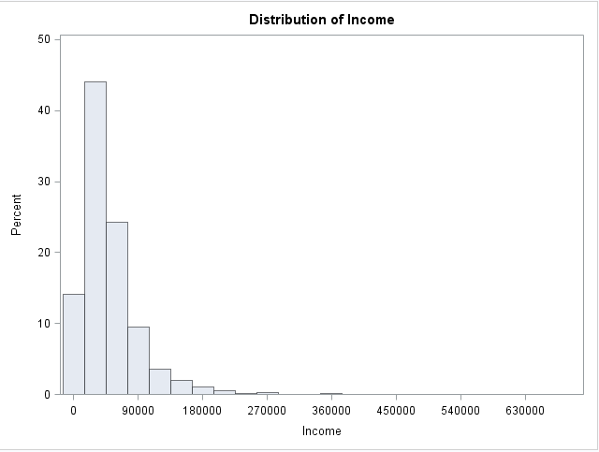From a previous study we can assume the standard deviations are equal. We also assume they are independent of each other and there’s no reason or evidence to suggest they are not. Normality may be a bit more of an issue. As the histogram shows there is skew but the population appears otherwise normal. The large sample size may help make up for this as well.
3. On the next page is the output from the ANOVA testing.

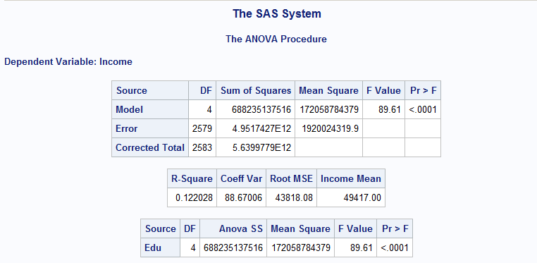

1. Given the very low p-value (<.0001) we can conclude that the income means of the differently educated people are not the same. Instead we conclude that at least one level of education has a different mean income than the rest (more than one may differ but we cannot conclude how many).
2. This study cannot be applied to the American population as a whole. The samples were randomly selected from a population which participated in a longitudinal study beginning in 1979. This means our conclusions can be applied to that population (the longitudinal study participants) but not to any larger group.
3. The R2 for this study is 0.122 which indicates that education accounts for 12.2% of the variation seen. Other sources of variation could include where the person lives, their specific profession, and their level of experience in that profession.
4. The mean square error is 1920024319.9 and the degrees of freedom used to calculate it was 2579 (2583 total minus 4 from the model).